Python Data types

Type(true) – type is predefined function – it will give the the Boolean class

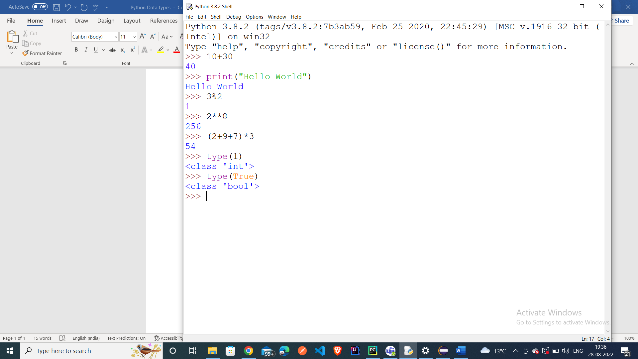

String in Python is a sequence of characters

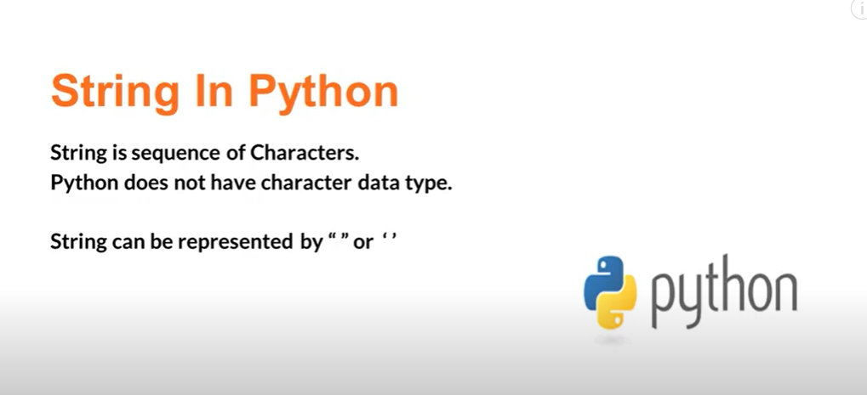

\\ - it will remove double quotes

\t – it will create space

\n it will create new line

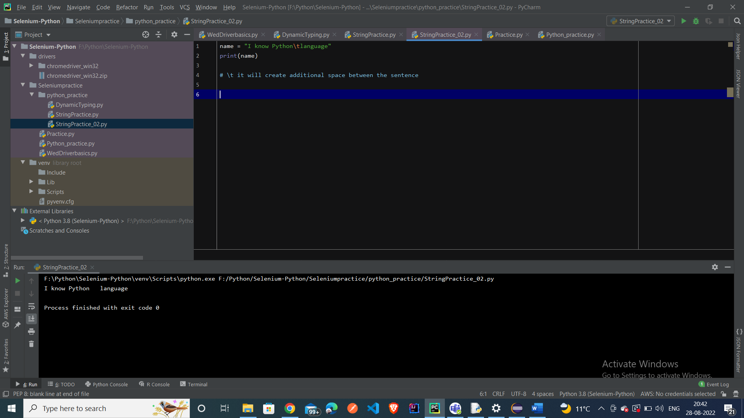

String class methods – len – it will give the length – index – it will give the position length inside the string

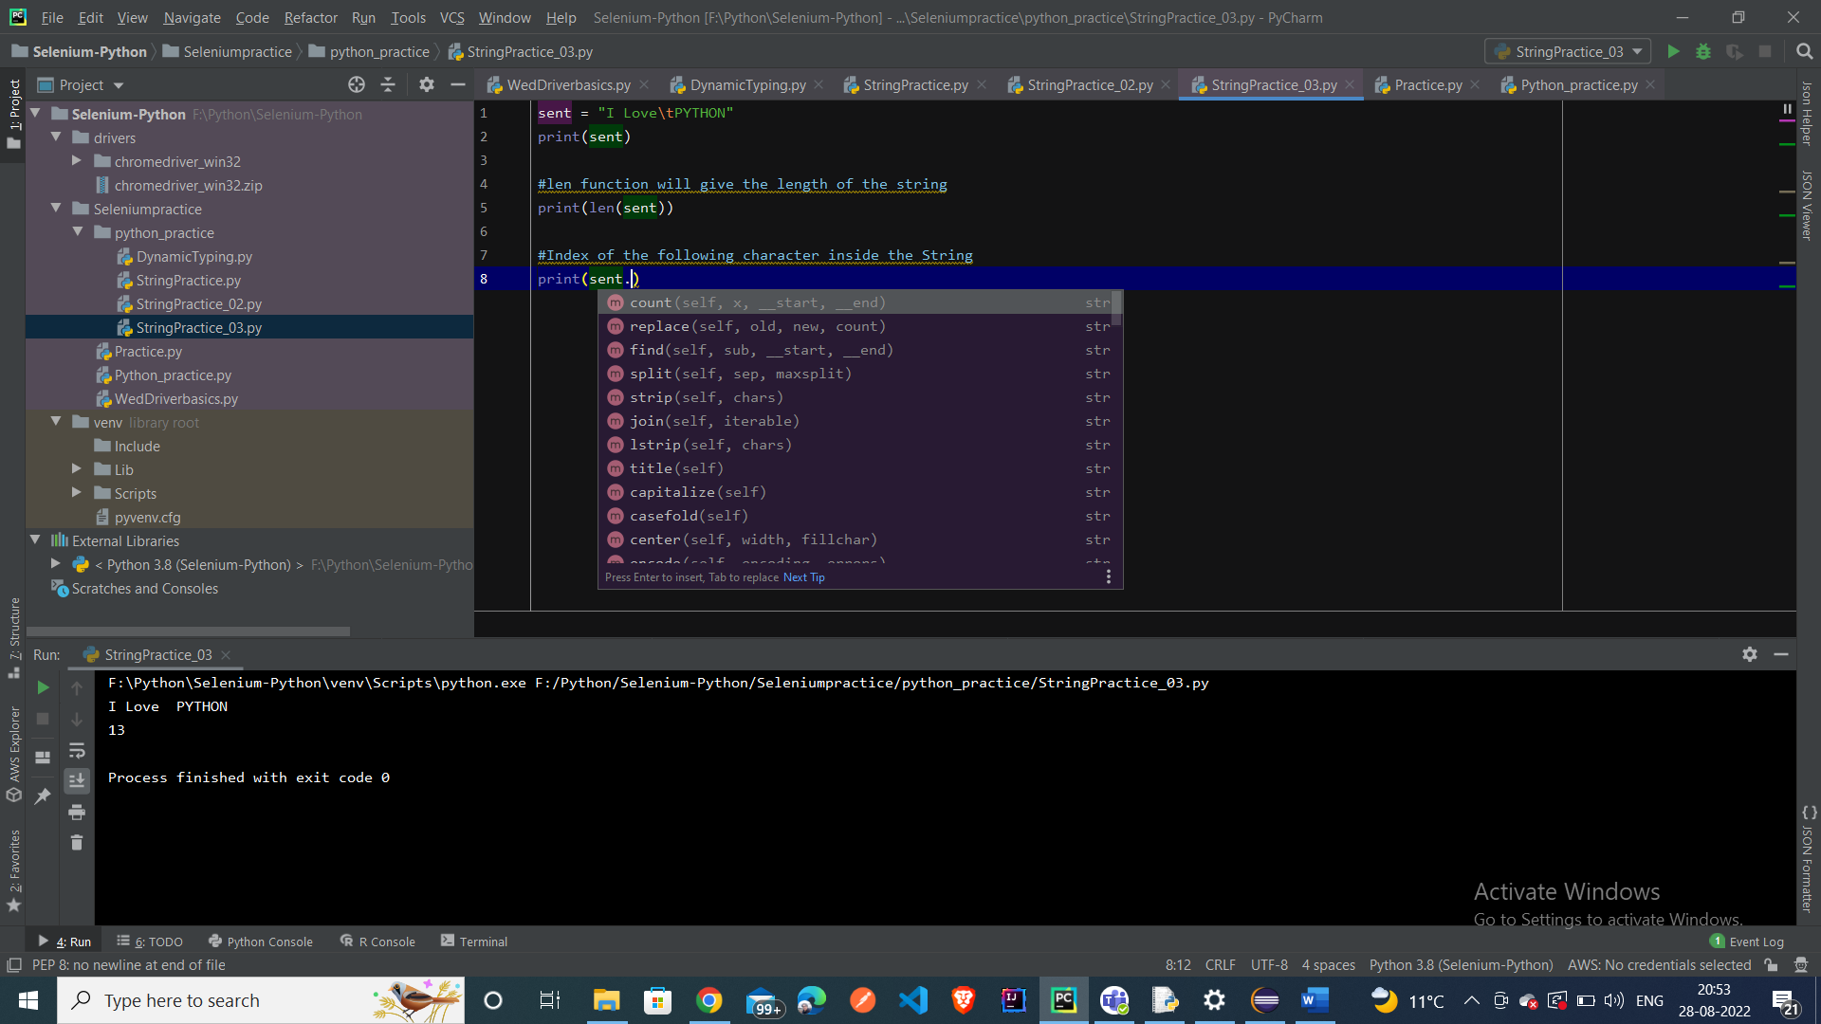

Replace mrthod in python

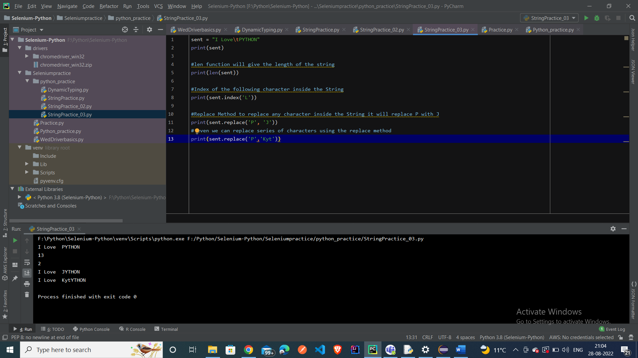

Format method

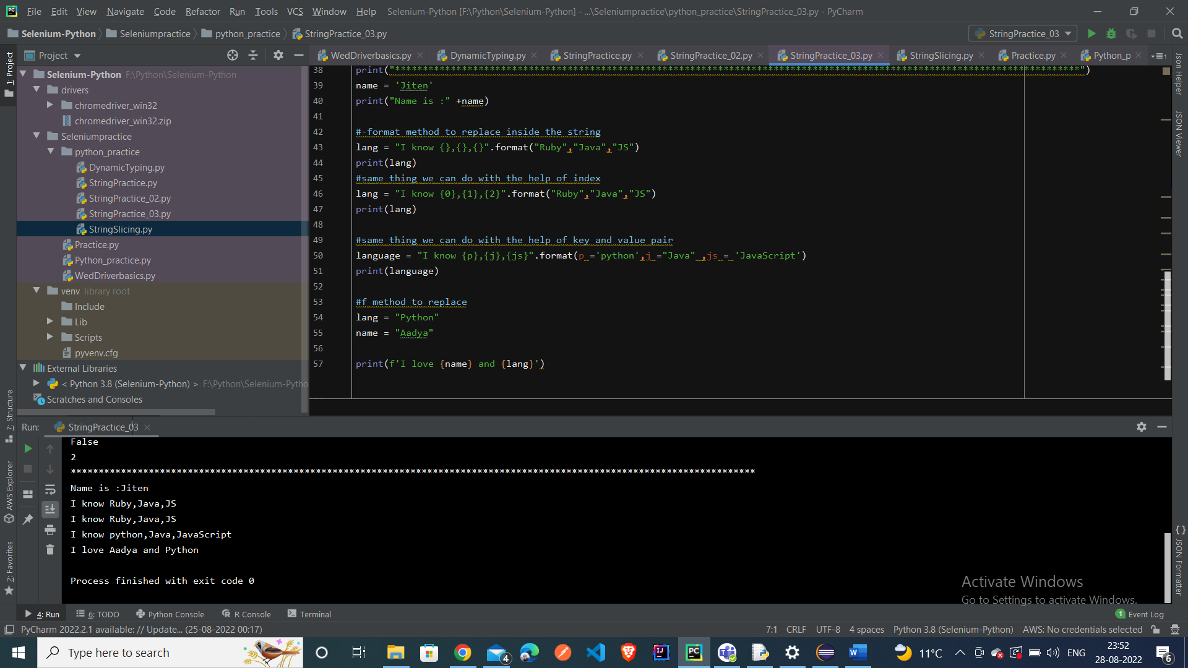

Slicing and indexing

LIST

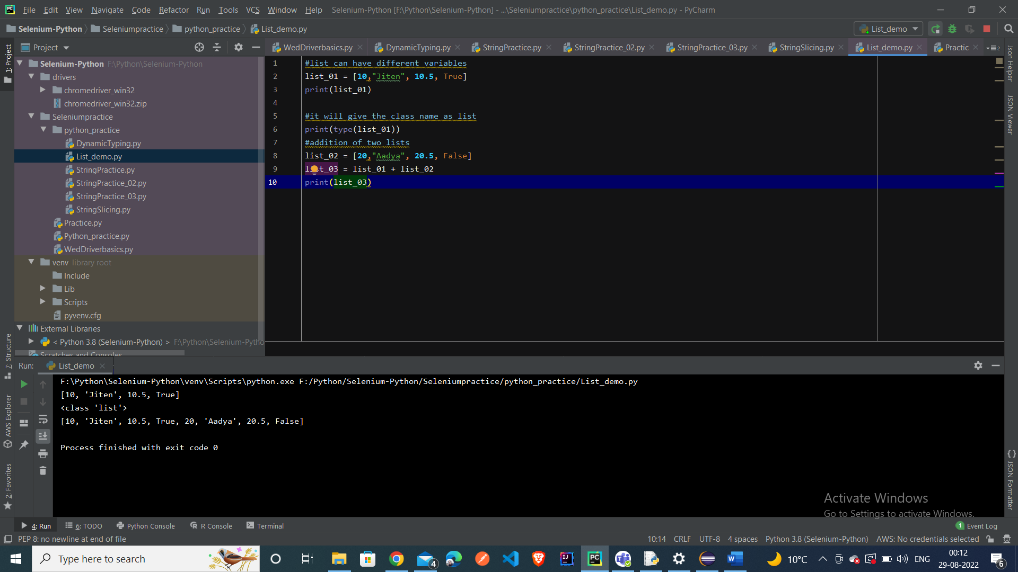

Indexing and Slicing in list

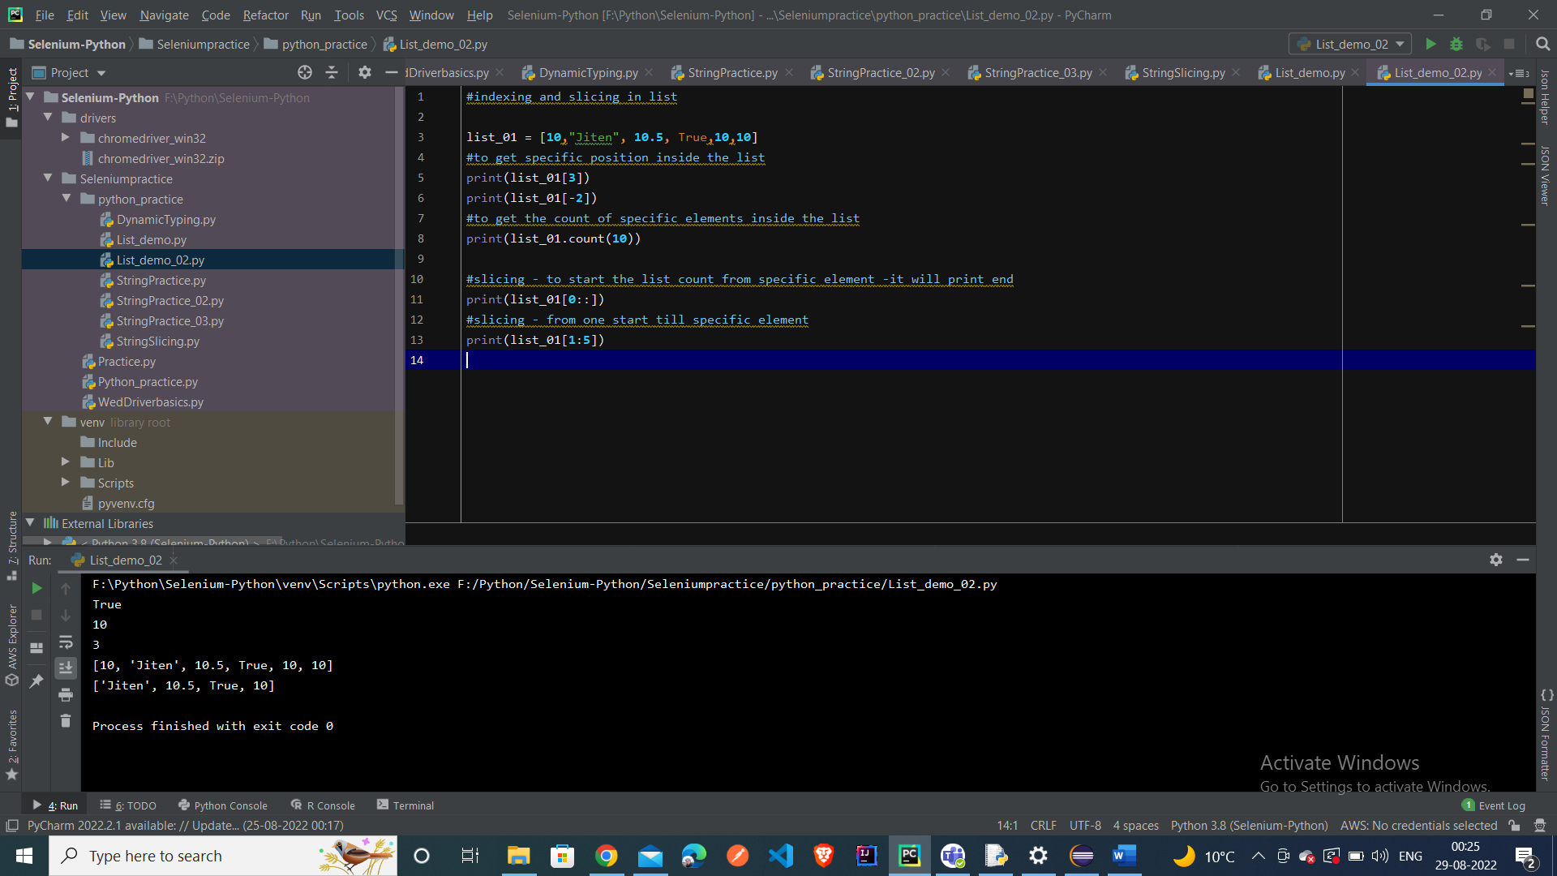

List extend – keyword to add additional elements inside the list

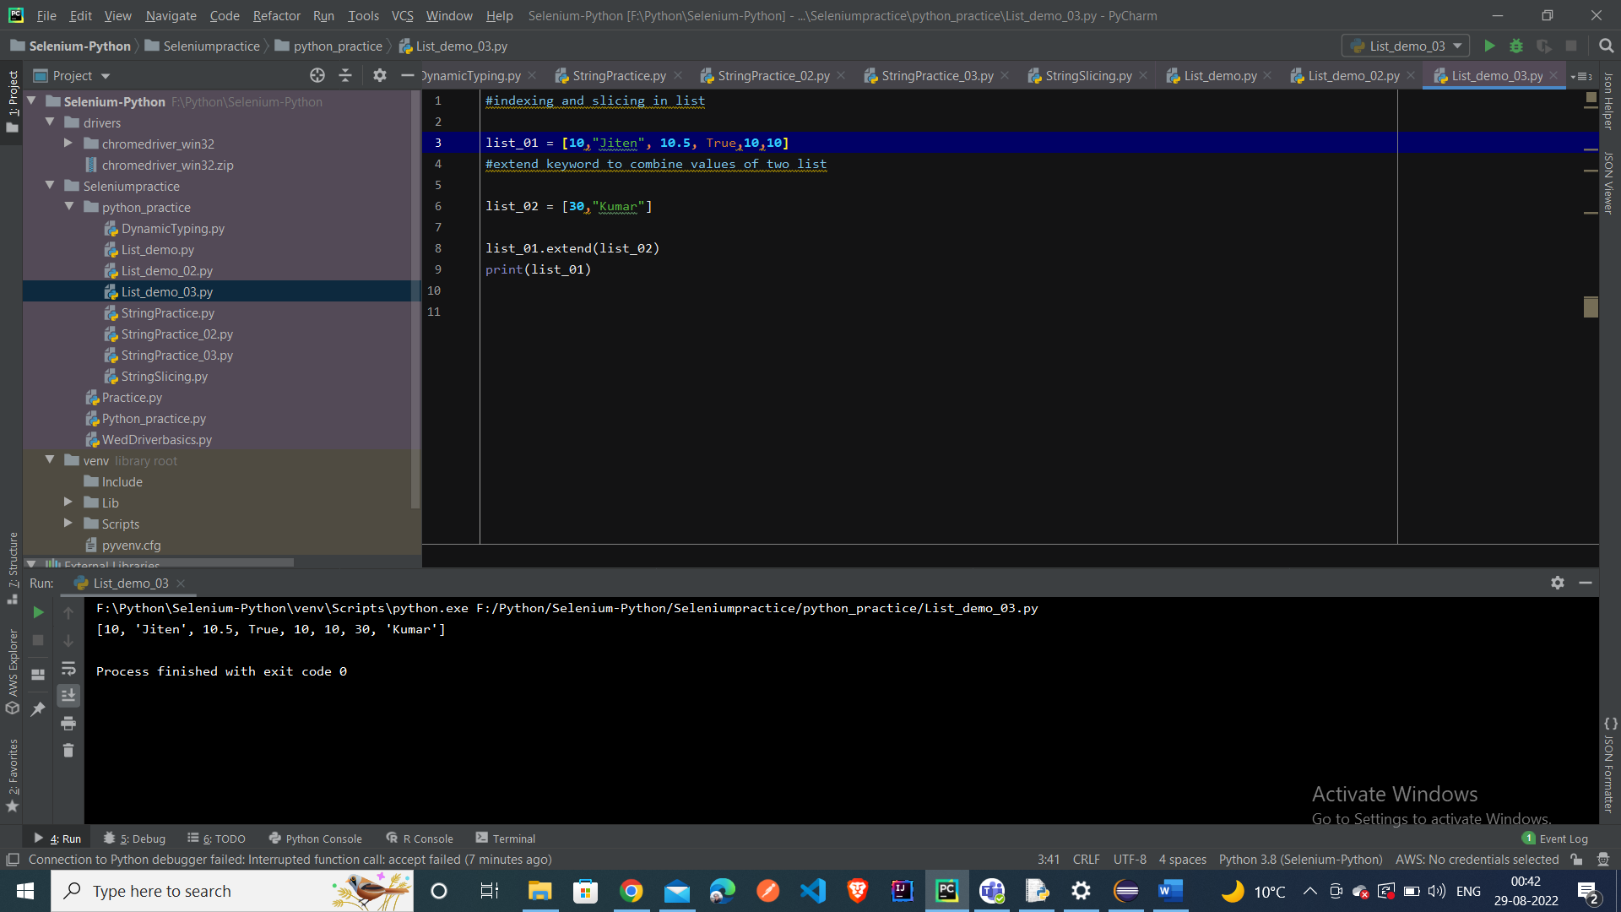

Set tutorial

To run python script in windows cmd terminal

